CS503 Capstone Multiplayer Game

Software Design Document

# High Level Design

|  |  |
| --- | --- |
| Stack | Technology |
| Frontend – client | HTML5 canvas, Socket.io |
| Frontend – server | Node.js, Socket.io |

expressJS

Socket.io

The game runs on a NodeJS and use Socket.io to create a WebSocket server to listen on certain port.

Use ExpressJS to setup a simple HTTP service that display index.html, which has Canvas element used to render the game and client side Javascript to communicate with Socket server.

# Modulization

## Game Client

Game Canvas:

Create Canvas to render the game (HTML)

Functions to render the game

Functions to check ping/latency

Functions to process game input

ChatBox:

Elements for the chatbox (HTML)

Functions to send chat message

Overall:

Socket event listener to communicate with server

## Game Server

Game logic:

Food mass

Movement

Eaten judgement

Random color

Hit test

Process movement

List:

Player list

Food list

Sockets list

# Interaction

## Authentication

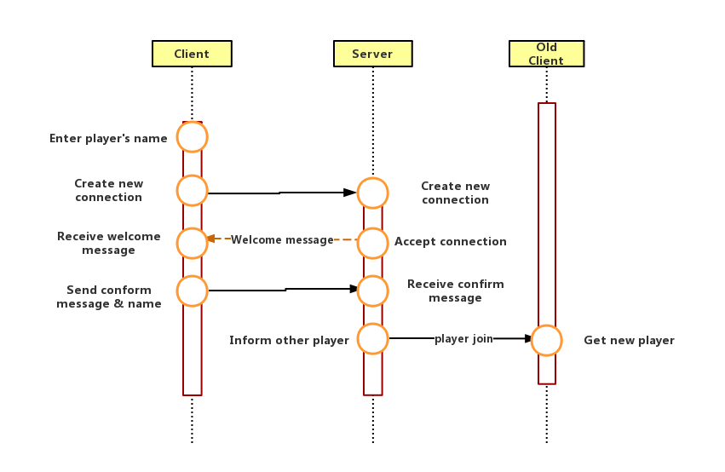

## In Game Communication

Game logic

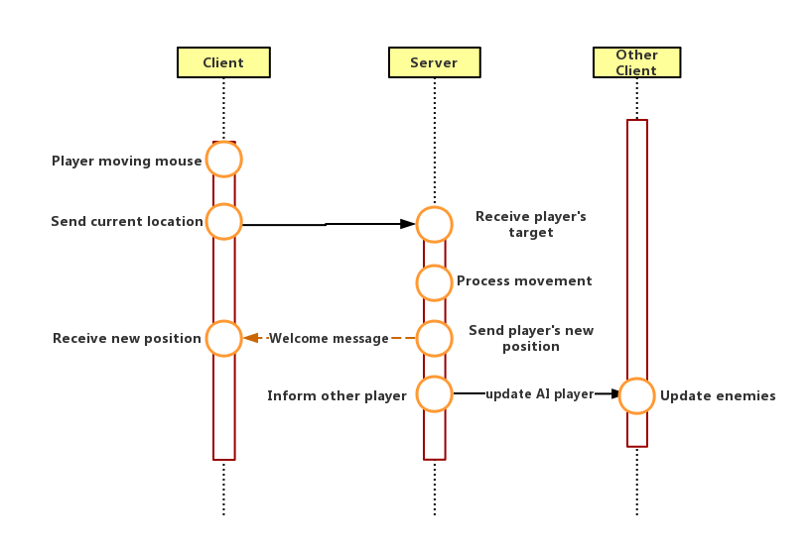

Eating food:

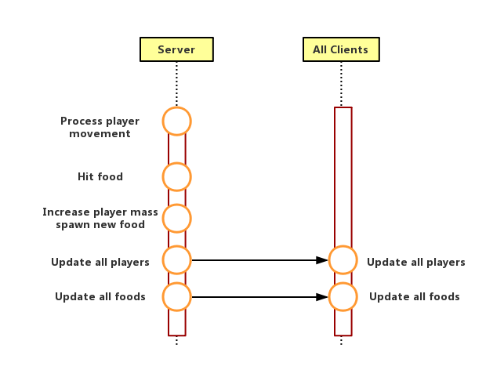

Eating player:

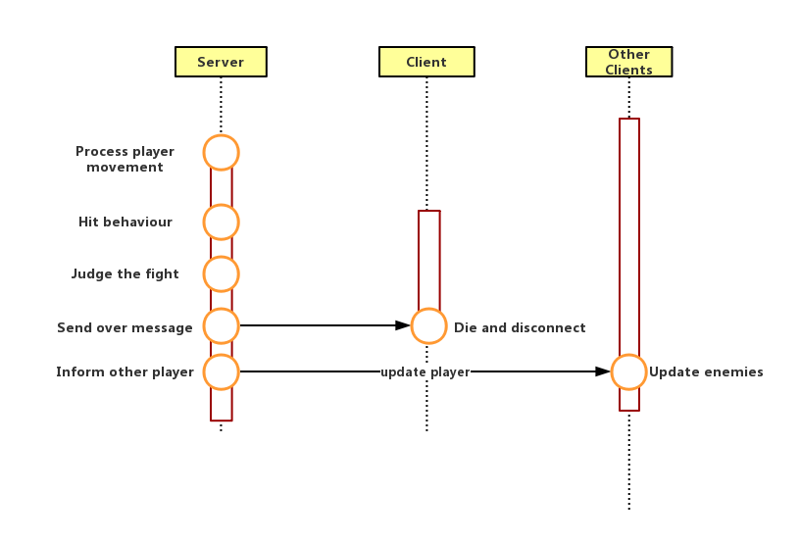

Chat:

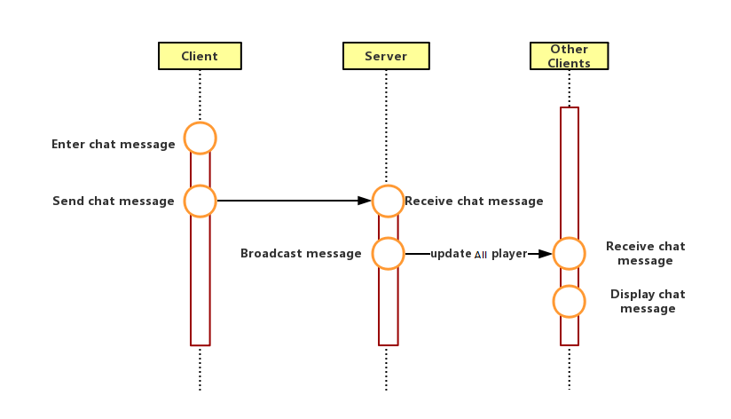

Latency:

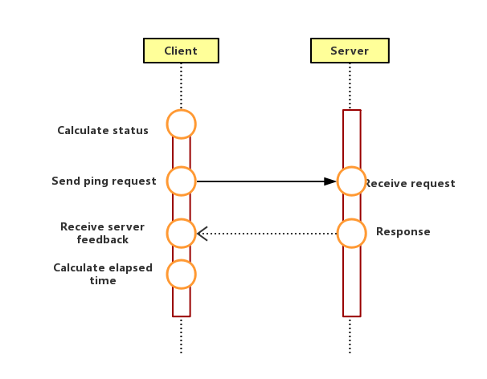

# Discussion